Empirical Network Analysis
Qiao Zhang
Sep 9th, 2012
Obtaining Data
Last semester, my friends and I created a questionnaire application called “Who knows me best” on Renren.com (the copycat version of Facebook in China), which allows users to generate their own questionnaire and invite their friends to answer. A user can create only one questionnaire while can answer several. (This app is available here, but only in Chinese) After a few months we have accumulated some data, and I always wanted to construct a graph of the users, hoping to find something interesting.
The user interface looked like this:
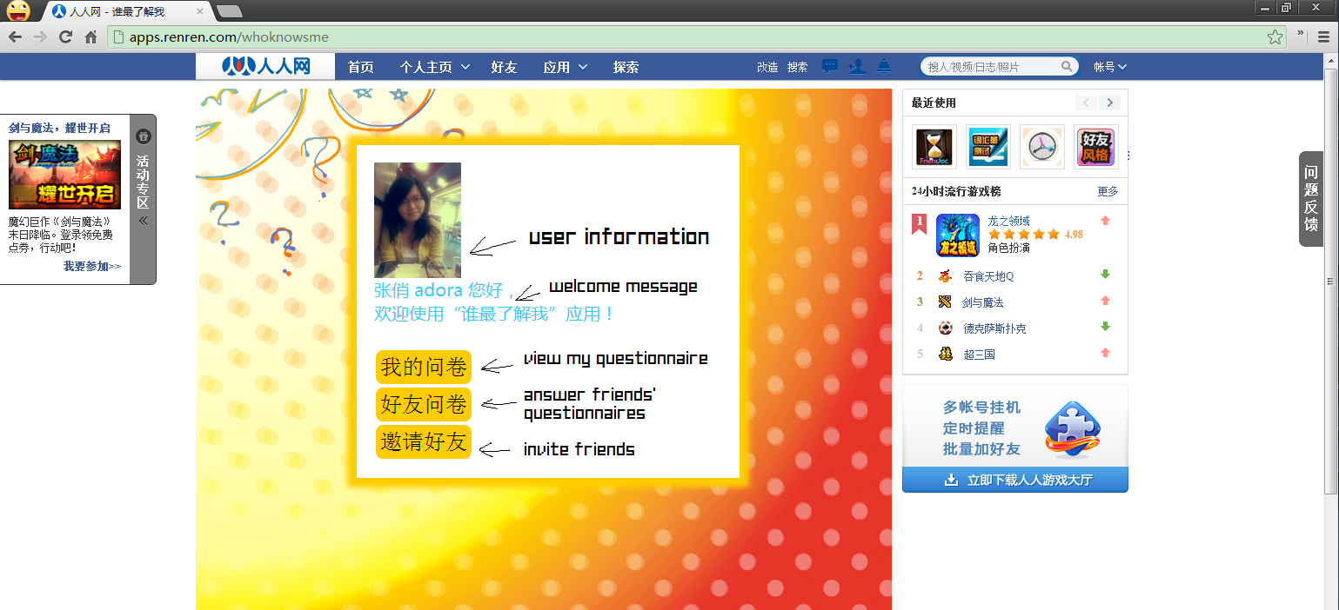
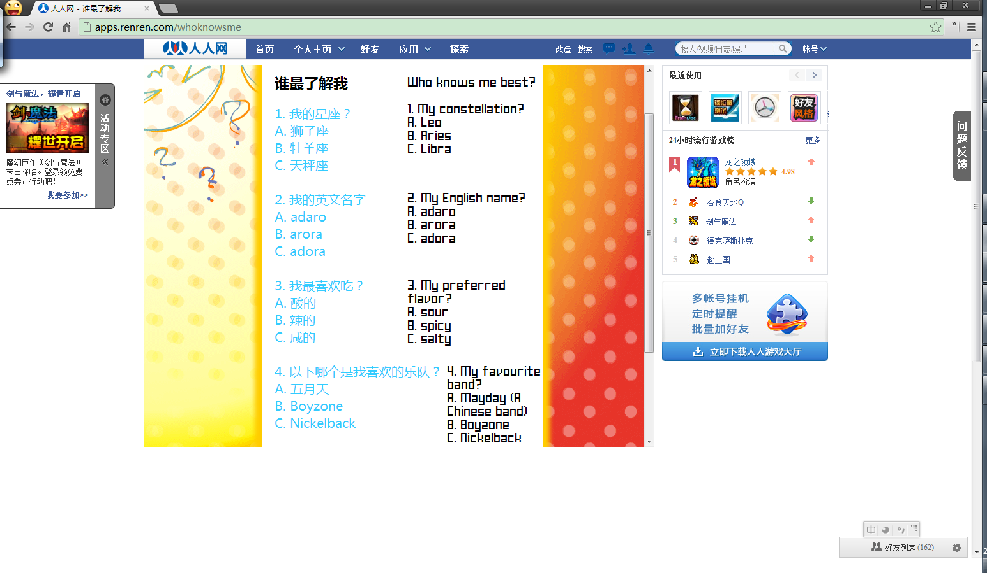
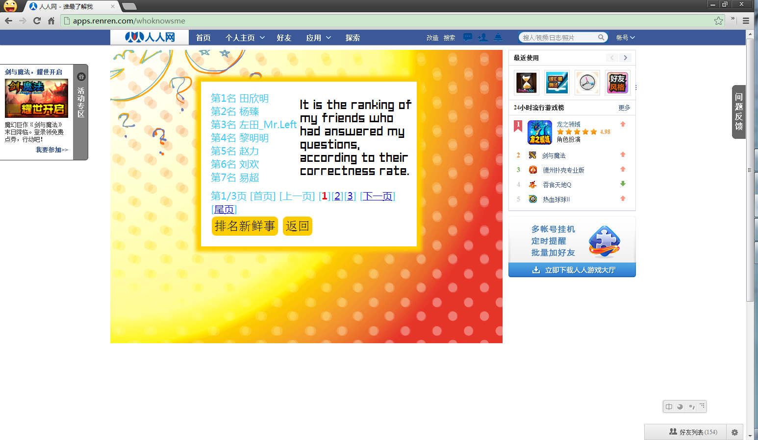
The database structure underlying this application is:
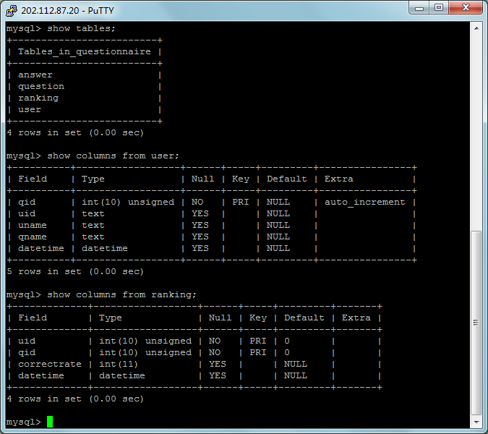

Because basically I only want information about the surveyers and respondents, I used the following SQL query to obtain the author IDs and the respondent IDs (For privacy reasons, I did not fetch users’ real names), which are the nodes of the graph. Therefore the edges of the graph would be the author-answerer relationship.
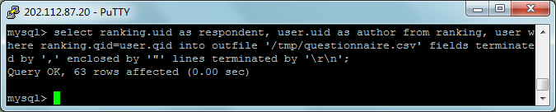

Data Analysis
The dataset:
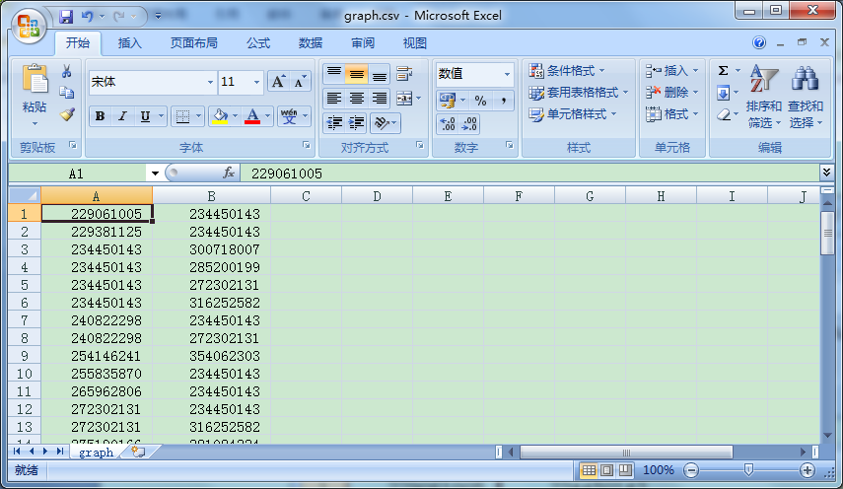

When the file is loaded in Gephi, the graph looked like this:
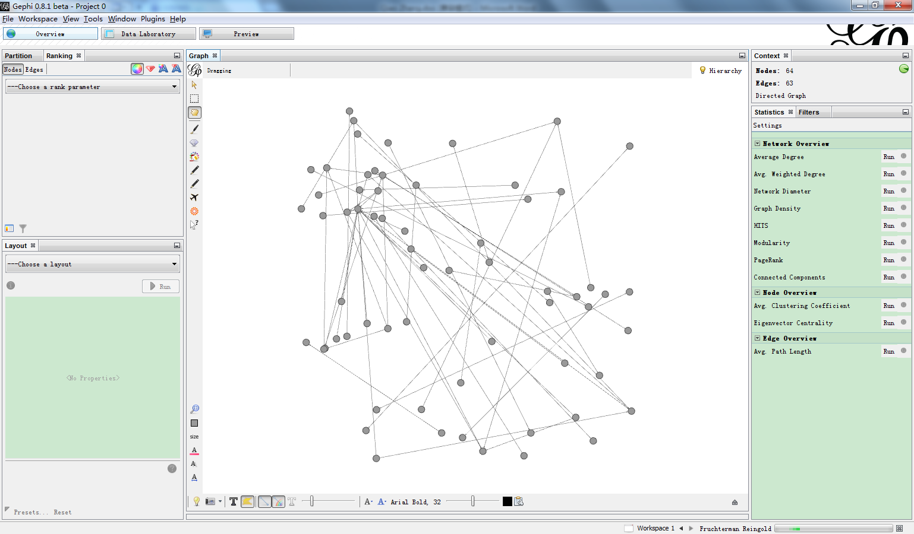
Although a bit chaotic, there is a node that seemed to have more degrees than the others, which is, me. This is because I actively called for my friends to try this app out, since I have labored over the development process.
To give the graph more clarity, a applied Fruchterman Reingold layout algorithm, a coloring algorithm (according to degree) and several other adjustments:
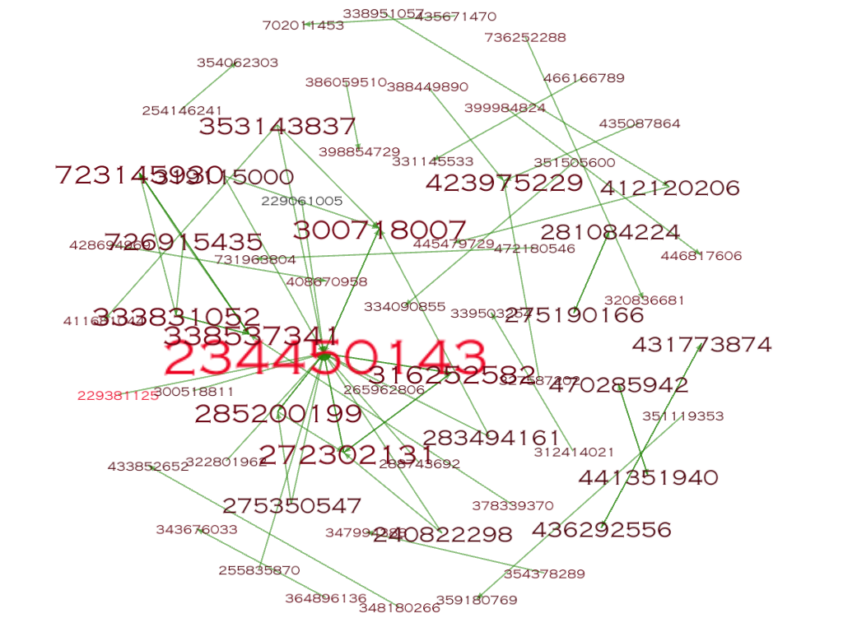
It turns out that 234450143 (me) is indeed the most important node.

In order to see the aggregations of the network, I applied Force Atlas layout algorithm:
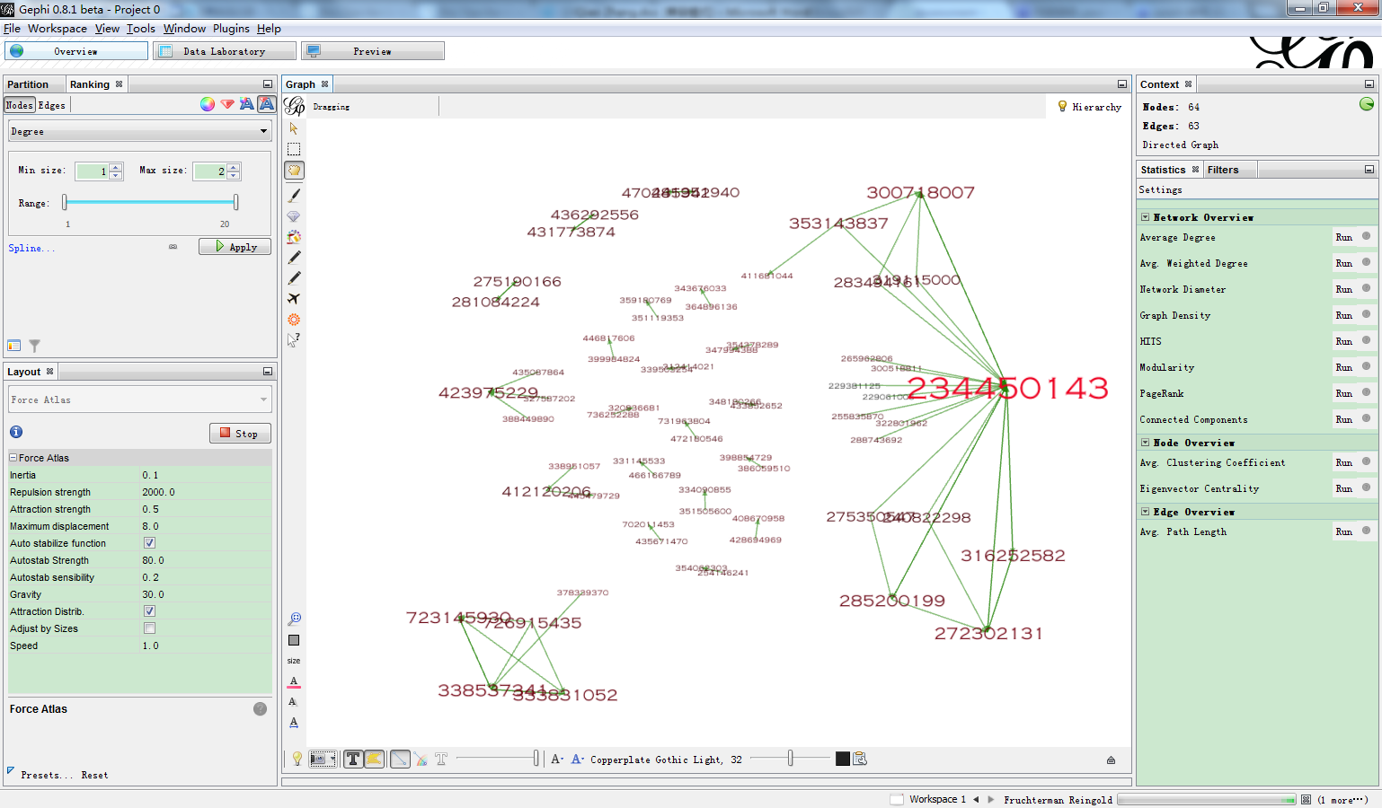
Then I see two clusters containing relatively more nodes, of which one is me, the other cluster might be another group of friends who had used our app. To my puzzlement, in the center shows up a number of nodes in pairs. After observing their profiles, I suddenly realized that these pairs are actually close friends and couples. Interestingly, if a pair of nodes are a couple of lovers, the answerer is always a boy. It is probably because our app’s name is “Who knows me best”, users are more likely to invite their best friends or girl(boy)friends rather than just random friends.
After calculating average path length (treat as undirected), the average path length is about 1.8, and number of shortest paths is 378, which might not be so meaningful because the graph is not completely connected. However, it indicates that this app is indeed used by intimate group of friends, rather than average friends, because the average path length is so short that is less than 2 hops. (the following graph ranked nodes by betweeness centrality)
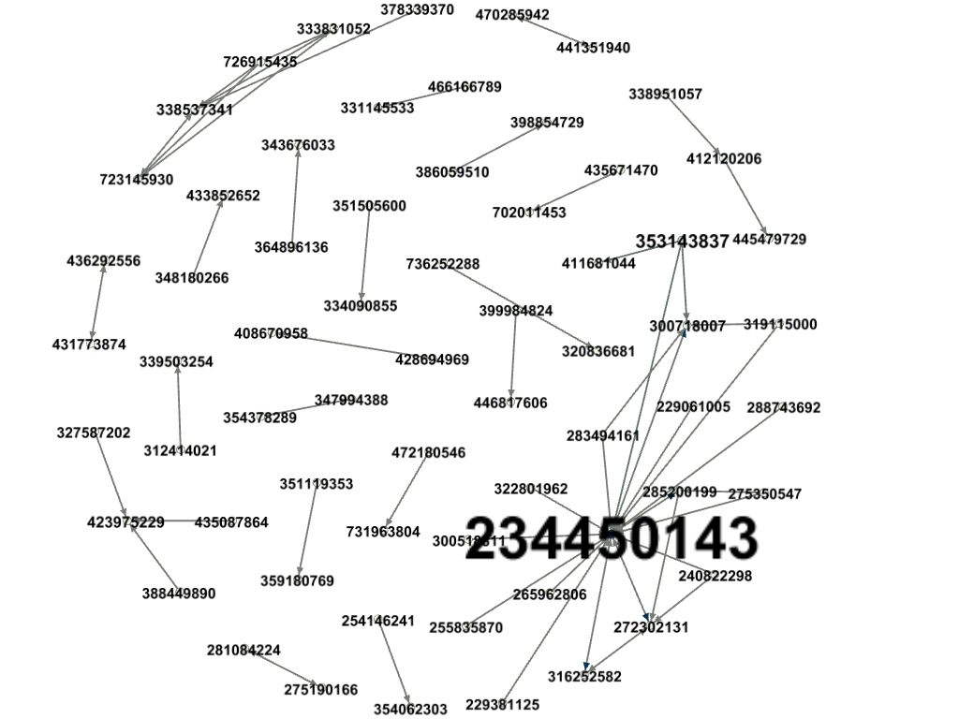
To take a further step on finding clusters, after running the modularity algorithm, the result shows:
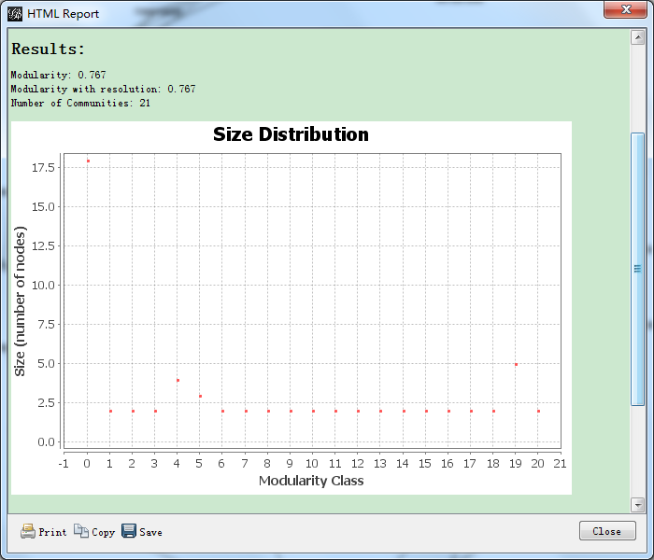
Of all modularity classes, seventeen classes consist of only 2 nodes, and one of 18 nodes. Which means the dataset might not be so good beacause the size distribution looks flat.
After grouping the communities:
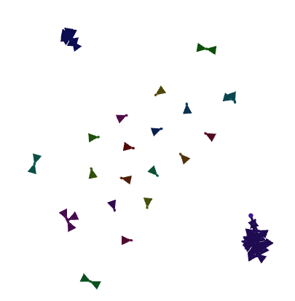

Because I want to find out which users are more active, I filtered the nodes by its out degree, selected those who has more than 2 out degrees, and the result shows that out of 64 users, only 12 had answered more than one questionnaire.
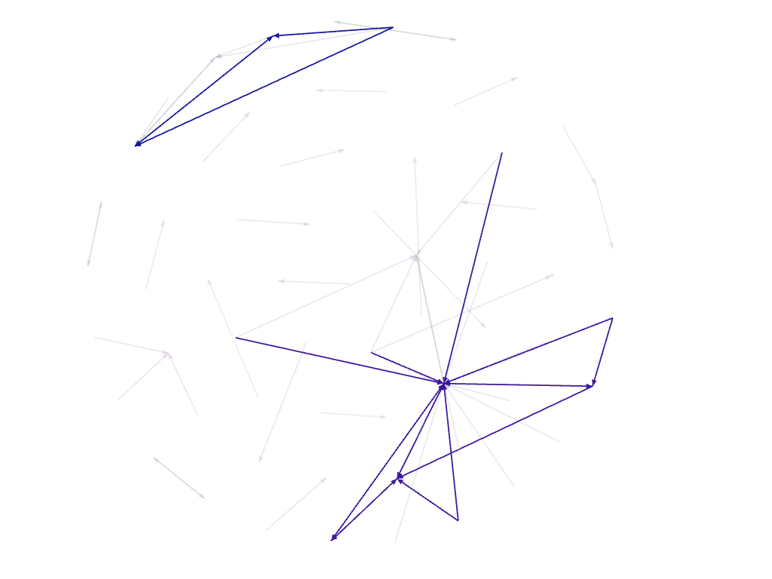

The graph is so sparse that I want to know how sparse it is. So I calculated the graph density, which is a measurement of how close the network is to complete. A complete graph has all possible edges and density equals to 1, and mine is 0.026, which is a pityfully sparse graph. It is because one will not invite average friends to answer his/her questionnaire, nor to answer questionnaires of them. So the edges are sparse, compared to the size of nodes.

The limitation of the analysis is that the dataset is too small, because we have not yet collected enough data. Later on when there are more users and questionnaires, the analysis itself and conclusions drawn may be more persuasive.

Dataset
229061005 234450143
229381125 234450143
234450143 300718007
234450143 285200199
234450143 272302131
234450143 316252582
240822298 234450143
240822298 272302131
254146241 354062303
255835870 234450143
265962806 234450143
272302131 234450143
272302131 316252582
275190166 281084224
275350547 234450143
275350547 285200199
281084224 275190166
283494161 234450143
283494161 300718007
285200199 234450143
285200199 272302131
288743692 234450143
300518811 234450143
300718007 234450143
312414021 339503254
316252582 234450143
316252582 272302131
319115000 234450143
319115000 300718007
322801962 234450143
327587202 423975229
333831052 338537341
333831052 723145930
338537341 723145930
338537341 333831052
338951057 412120206
348180266 433852652
351119353 359180769
351505600 334090855
353143837 411681044
353143837 234450143
353143837 300718007
354378289 347994388
364896136 343676033
378339370 338537341
386059510 398854729
388449890 423975229
399984824 446817606
412120206 445479729
428694969 408670958
431773874 436292556
435087864 423975229
435671470 702011453
436292556 431773874
441351940 470285942
466166789 331145533
470285942 441351940
472180546 731963804
723145930 338537341
726915435 338537341
726915435 723145930
726915435 333831052
736252288 320836681

